Chapter 17, Solution 16.

The waveform in Fig. 17.55(a) has the following Fourier series:

Obtain the Fourier series of v₂(t) in Fig. 17.55(b).

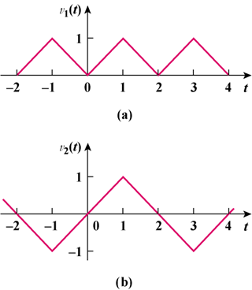

Figure 17.55
For Prob. 17.16.

Solution

If v₂(t) is shifted by 1 along the vertical axis, we obtain v₂*(t) shown below, i.e. v₂*(t) = v₂(t) + 1.

t

5

4

3

2

1

0

-1

-2

2

v₂*(t)

1

Comparing v₂*(t) with v₁(t) shows that

v₂*(t) = 2v₁((t + t_{o})/2)

where (t + t_{o})/2 = 0 at t = -1 or t_{o} = 1

Hence v₂*(t) = 2v₁((t + 1)/2)

But v₂*(t) = v₂(t) + 1

v₂(t) + 1 = 2v₁((t+1)/2)

v₂(t) = -1 + 2v₁((t+1)/2)

= -1 + 1

v₂(t) =

v₂(t) =

